Scientific Management
Definition: Scientific management concept was developed by F.W. Taylor who implemented the scientific techniques such as observation, logic, analysis and combination to study the working conditions and management at the floor level in the factories and production units.

Management
- Frederick Taylor and Scientific Management
- Principles
  - Science Not Rule of Thumb
  - Harmony Not Discord
  - Cooperation Not Individualism
  - Development of Every Person to His or Her Greatest Efficiency and Prosperity
- Techniques
  - Functional Foremanship
  - Standardization and Simplification of Work
  - Time Study
  - Differential Piece Wage System
  - Mental Revolution
  - Performance standards
  - Fatigue and motion study
- Criticism
- Worker’s Point of View
- Employer’s Point of View

Frederick Taylor and Scientific Management
Frederick Winslow Taylor (1856-1915) was an American mechanical engineer and a consultant who proposed the concept of scientific management under the name ‘The Principles of Scientific Management’ in the year 1911. He was also known as the ‘Father of Scientific Management’.
Taylor made observations regarding the inexcusable work methods in the companies like Bethlehem Steel, Simonds Rolling Machine and Midvale Steel.
In that era, there was a scarcity of skilled labour in the industries. Taylor found that the organizations and the managers failed to utilize the available human resources effectively, and also, no contribution was made in the direction of enhancing the labour’s efficiency.
During his observation, Taylor identified the various factors leading to low productivity and inefficiency in the organization. Some of these are as follows:
- The labour brought their poorly designed personal tools to be used in the workplace.
- Unorganized job training was provided to the workers, and they tend to decide the speed of the work and machine by themselves.
- Instead of the individual’s skills set, the workers were hired according to the ‘first-come, first-hired’ basis.
- The managers used to work along with labours leaving aside the essential planning and organizing activities. Thus, these crucial management functions were performed by untrained employees.
Based on his findings, Taylor criticized the ineffective ways of the managers to handle the work situations and also for providing liberty to the employees for deciding their work methods and speed by themselves.

Principles of Scientific Management
Taylor suggested four important tenets based on his findings and research of the production areas of some renowned companies. These are as follows:

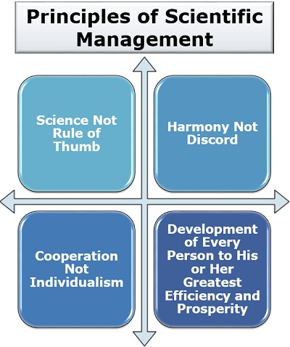

Science Not Rule of Thumb
The concept of the rule of thumb was based on the trial and error method. However, Taylor believed that to perform any task efficiently; there is only one best possible method which is developed after an in-depth analysis of that job.
Thus, it becomes the standard way of carrying out that particular task each time, throughout the organization.
When science is applied instead of the rule of thumb, to any job, it standardizes that work. Moreover, the workers get a specialized way of performing the task and wastage of a lot of time, cost and resources can be avoided.

Harmony Not Discord
Taylor emphasized on maintaining peace and harmony in the workplace, and there should be no conflict among the managers and the workers. Conflicts only result in negatively, i.e., a decline in the productivity of the organization.
There can be a significant improvement and growth in productivity if there exists a friendly relationship between the managers and the labours where both value the efforts of each other,
Thus, there should be a mental revolution in the organization to change how both groups see each other.

Cooperation Not Individualism
An organization is made up of different individuals (i.e., personnel), and each one of them is equally important. Business is all about teamwork and cooperation, in the absence of which the organization may fail to attain the desired results.
Therefore, the employees in an organization must work together, keeping aside their objectives and ego to achieve the common goals set by the management. There should not be any competition among the workers; instead, they should cooperate at work.
The workers should not oppose the management by putting up irrelevant demands and then going on strikes for their fulfilment. The administration should also encourage the workers to give suggestions and create an open communication system in the organization.

Development of Every Person to His or Her Greatest Efficiency and Prosperity
Taylor believed that employees should be given proper training of the task they perform because no human being is perfect, and there is always a scope of improvement.
Moreover, training and development improve the competency, skills and learning of the workforce. It is beneficial for both the organization and the workers.

Techniques of Scientific Management
Along with the scientific management principles, Taylor also introduced some methods to improve the productivity of the workers and ensure smooth functioning of the organization.
These methods were majorly developed for the manufacturing and production industry and were based on his analysis of such units.
Let us now discuss each of these techniques in detail below:

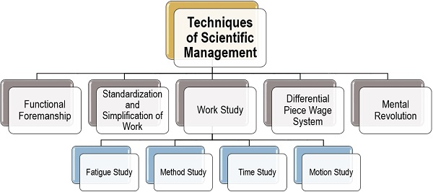

Functional Foremanship
Taylor suggested that to improve efficiency and effectiveness of the operational activities the managers must possess specific skills like leadership, intelligence, tactical skills, knowledge, judgment, education, experience, honesty, good health and energy.
He realized that no single person could have all of these qualities. Therefore, he came up with the idea that the managerial activities should be divided into two parts, i.e., planning and production.
Also, there should be two individual in charges appointed under the factory manager for carrying out both of these activities holding the position of planning incharge and production incharge, respectively.
Moreover, there should be four different clerks under each of the incharge, i.e., the planning incharge and production incharge. They hold expertise in their respective areas and supervise the performance of each worker.
Let us now see the hierarchy under the functional foremanship as suggested by F.W. Taylor:

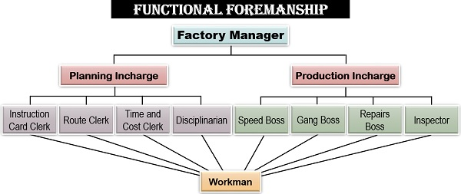

Factory Manager
A factory manager is a person who holds the highest managerial position in the unit and is responsible for the proper functioning of the organization.
Planning Incharge: A planning incharge is responsible for the formulation of policies, strategies and procedures of the operational activities. To simplify the work, following four clerks are appointed under the planning incharge:
- Instruction Card Clerk: The instruction card clerk will determine and direct how the work has to be performed.
- Route Clerk: A route clerk will decide what all is to be done and the steps which are to be taken to perform a particular task.
- Time and Cost Clerk: The person who determines the time limit in which the work is to be completed and the cost involved in carrying out each task is known as a time and cost clerk.
- Disciplinarian: A disciplinarian is a clerk who ensures discipline, following rules and regulations and code of conduct in the organization.
Production Incharge: A production incharge needs to take care of all the operational and production activities. The four clerks assigned under a production incharge are as follows:
- Speed Boss: The speed boss is responsible for getting the work done on time.
- Gang Boss: The person who looks after the availability of all the equipment, tools and accessories is a gang boss.
- Repairs Boss: The repairs boss has to take care of the repairs, maintenance and overhauling of the tools and machinery used for production.
- Inspector: The inspector is responsible for ensuring that all activities are being carried out in a planned manner. He/she also checks whether the quality of the products are as per the standards or not.

Workman
A workman is a labour or the worker at the operational level of the organization which is responsible for actually performing the given task. Each worker is supervised and monitored by the eight different clerks, as mentioned above.
Therefore, we can also interpret that the functional foremanship is the only scientific management technique, which is ‘contrary to the principle of unity of command’.

Standardization and Simplification of Work
Taylor suggested that there should be a fixed standard for everything, i.e., the product, raw material, process, machinery and working conditions. This is to save the time and cost and bring in specialization in the organization.
Also, the task and the product line should be simplified enough to save the extended cost of tools, machine and labour by eliminating the unproductive tasks and narrowing the product line.

Work-Study
Taylor emphasized on examining and analyzing the working at the operational level of the organization. It develops a systematic course of action and resolves the problems faced by the labours and workers who are responsible for accomplishing the given task and duties.
Under the technique of work-study, there are following four significant concerns of the organization:
Fatigue Study
According to Taylor, the task can be accomplished effectively and efficiently only if the worker is allowed to take the required amount of rest during the working hours.
Under the fatigue study, the organization needs to plan for the following:
- The number of rest intervals: The organization needs to decide the number of times, for which rest is allowed to the labours in a day.
- Frequency of rest intervals: The time interval after which the employee’s rest time is scheduled is termed as the frequency of the rest intervals.
- Duration of each rest interval: The organization also determine the period of each rest interval. Such that the worker neither remains exhausted nor moves into a state of laziness.
Method Study
The managers come across numerous ways of performing a particular task or carrying out the production of goods or services.
Out of all these possible methods, selection of the most appropriate way, which is cost-effective and also increases the production is considered a method study.
Time Study
Analyzing the time consumed for carrying out the given task in a specified manner is Taylor’s another scientific management technique which is called a time study.
If an activity takes more time than the defined standard, it may lead to delay and decline in productivity. And if a task is accomplished much before the given time, it may lack efficiency.
Motion Study
The examining of every movement of the workers during the working hours to find out the unproductive task and activities comes under motion study.
The actions and movements which do not generate any output should be eliminated to simplify the work.

Differential Piece Wage System
The wages paid to the workers should be based on their production capability, i.e., the number of pieces labour can manufacture in a given period, instead of a fixed rate of remuneration.
A standard number of units of production should be determined, and the wages should be decided accordingly. If a worker is unable to produce the usual quantity, then some amount will be deducted from the decided remuneration. However, if a worker produces more than the standard number of units, he or she will be liable for additional compensation.
In simple terms, Taylor suggested the ideas of performance-based remuneration and incentive-based motivation.

Mental Revolution
Taylor gave a powerful concept on changing the perception of both the employees and the management. Here, both of them work in collaboration and consider themselves as members of a family.
He said, to achieve the organizational goals efficiently, there must be proper coordination and understanding among the workers and the management. A friendly and cordial work environment leads to the growth of the organization as well as the individuals.
The employees should not consider themselves as just the workers of the organization, but believe themselves to be the members of a family. Even the management must understand that the workers are also human beings and an essential part of the organization. Both of them must value the efforts of each other and work together, creating a positive environment to achieve common organizational goals and objectives.

Criticism of Scientific Management
Scientific management has been criticized by many scholars due to its following shortcomings for the workers as well as the employers:

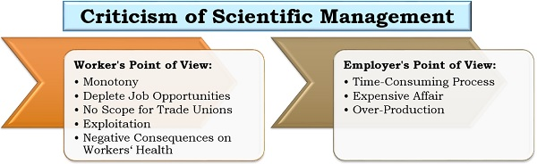

Criticism from the Worker’s Point of View
Scientific management leads to monotony for the workers since they need to use standardized ways and cannot implement their innovation and creativity to their work.
Workers felt that the management is upgrading with technology by employing new machines to deplete job opportunities.
Due to scientific management, a standardized system is developed in the organization. Here, the wage rate, compensation, working duration, rest intervals are fixed, thus leaving no scope for the trade unions to work for the labour welfare.
The workers claim that scientific management results in their exploitation. Since they believe that a hike in the wage rate is not proportionate to the increase in production, i.e., it is usually less.
This concept emphasizes on completion of work within the given standard time of output, therefore, leading to the acceleration of work which has negative consequences on workers’ health.

Criticism from the Employer’s Point of View
The employer considers scientific management as a time-consuming process since it takes very long to bring mental revolution and implement standardization and specialization in the organization.
The implementation of scientific management is an expensive affair. A lot of costs are incurred on the planning and training of the workers and the administration.
This concept focuses on increasing productivity of the organization; however, it may lead to over-production, which further results in recession.

Planning
Definition: Planning is the fundamental management function, which involves deciding beforehand, what is to be done, when is it to be done, how it is to be done and who is going to do it. It is an intellectual process which lays down an organisation’s objectives and develops various courses of action, by which the organisation can achieve those objectives. It chalks out exactly, how to attain a specific goal.
Planning is nothing but thinking before the action takes place. It helps us to take a peep into the future and decide in advance the way to deal with the situations, which we are going to encounter in future. It involves logical thinking and rational decision making.
Characteristics of Planning
Managerial function: Planning is a first and foremost managerial function provides the base for other functions of the management, i.e. organising, staffing, directing and controlling, as they are performed within the periphery of the plans made.
Goal oriented: It focuses on defining the goals of the organisation, identifying alternative courses of action and deciding the appropriate action plan, which is to be undertaken for reaching the goals.
Pervasive: It is pervasive in the sense that it is present in all the segments and is required at all the levels of the organisation. Although the scope of planning varies at different levels and departments.
Continuous Process: Plans are made for a specific term, say for a month, quarter, year and so on. Once that period is over, new plans are drawn, considering the organisation’s present and future requirements and conditions. Therefore, it is an ongoing process, as the plans are framed, executed and followed by another plan.
Intellectual Process: It is a mental exercise at it involves the application of mind, to think, forecast, imagine intelligently and innovate etc.
Futuristic: In the process of planning we take a sneak peek of the future. It encompasses looking into the future, to analyse and predict it so that the organisation can face future challenges effectively.
Decision making: Decisions are made regarding the choice of alternative courses of action that can be undertaken to reach the goal. The alternative chosen should be best among all, with the least number of the negative and highest number of positive outcomes.
Planning is concerned with setting objectives, targets, and formulating plan to accomplish them. The activity helps managers analyse the present condition to identify the ways of attaining the desired position in future. It is both, the need of the organisation and the responsibility of managers.
Importance of Planning
It helps managers to improve future performance, by establishing objectives and selecting a course of action, for the benefit of the organisation.
It minimises risk and uncertainty, by looking ahead into the future.
It facilitates the coordination of activities. Thus, reduces overlapping among activities and eliminates unproductive work.
It states in advance, what should be done in future, so it provides direction for action.
It uncovers and identifies future opportunities and threats.
It sets out standards for controlling. It compares actual performance with the standard performance and efforts are made to correct the same.
Planning is present in all types of organisations, households, sectors, economies, etc. We need to plan because the future is highly uncertain and no one can predict the future with 100% accuracy, as the conditions can change anytime. Hence, planning is the basic requirement of any organization for the survival, growth and success.

Steps involved in Planning

Setting Objectives
This is the primary step in the process of planning which specifies the objective of organisation i.e. what an organisation wants to achieve.
The planning process begins with the setting of objectives.
Objectives are end results which the management wants to achieve by its operations.
Objectives are specific and are measurable in terms of units.
Objectives are set for the organisation as a whole for all departments and then departments set their own objectives within the framework of organisational objectives.
Example:
A mobile phone company sets the objective to sell 2,00,000 units next year, which is double the current sales.
(2) Developing Planning Premises
Planning is essentially focused on the future and there are certain events which are expected to affect the policy formation.
Such events are external in nature and affect the planning adversely if ignored.
Their understanding and fair assessment are necessary for effective planning.
Such events are the assumptions on the basis of which plans are drawn and are known as planning premises.
Example:
The mobile phone company has set the objective of 2,00,000 units sale on the basis of forecast done on the premises of favourable Government policy towards digitization of transactions.
(3) Identifying Alternative Courses of Action
Once objectives are set, assumptions are made.
Then the next step is to act upon them.
There may be many ways to act and achieve objectives.
All the alternative courses of action should be identified.
Example:
The Mobile company has many alternatives like reducing price, increasing advertising and promotion, after sale service etc.,
(4) Evaluating Alternative Course of Action
In this step, the positive and negative aspects of each alternative need to be evaluated in the light of objectives to be achieved.
Every alternative is evaluated in terms of lower cost, lower risks, and higher returns, within the planning premises and within the availability of capital.
Example:
The mobile phone company will evaluate all the alternatives and check its pros and cons.
(5) Selecting One Best Alternative
The best plan which is the most profitable plan and with minimum negative effects is adopted and implemented.
In such cases, the manager’s experience and judgement play an important role in selecting the best alternative.
Example:
Mobile phone company selects more T.V advertisements and online marketing with great after sales service.
(6) Implementing the Plan
This is the step where other managerial functions come into the picture.
This step is concerned with “DOING WHAT IS REQUIRED”
In this step, managers communicate the plan to the employees clearly to convert the plans into action.
This step involves allocating the resources, organising for labour and purchase of machinery.
Example:
Mobile phone company hires salesman on a large scale, creates T.V advertisement, and starts online marketing activities and set up service workshops.
(7) Follow Up Action
Monitoring the plan constantly and taking feedback at regular intervals is called follow-up.
Monitoring of plans is very important to ensure that the plans are being implemented according to the schedule.
Regular checks and comparisons of the results with set standards are done to ensure that objectives are achieved.
Example:
A proper feedback mechanism was developed by the mobile phone company throughout its branches so that the actual customer response, revenue collection, employee response, etc. could be known.

By planning process, an organisation not only gets the insights of the future, but it also helps the organisation to shape its future. Effective planning involves simplicity of the plan, i.e. the plan should be clearly stated and easy to understand because if the plan is too much complicated it will create chaos among the members of the organisation. Further, the plan should fulfil all the requirements of the organisation.

