Student’s Council Report 2022-23
Student council for the year is formed in the month of August 2022.The committee is formed with the students consisting of representatives of NSS, Gymkhana, Art circle and one representative of backward caste, one student nominated by principal and other students representing the other classes.
College General Secretary and lady representative is unanimously selected. Mr Shubham Narvekar was selected as General secretary and Miss Suvidha Sawant as Ladies’ representative.
Under the able guidance of Principal, Convener and other teacher members, Student members were actively involved in maintaining discipline at various events in the college and conducting various college activities . Birth Anniversaries of National leaders was celebrated by them and student members also assisted IQAC in their student related work. They were also actively involved in Academic audit committee visit to college.
T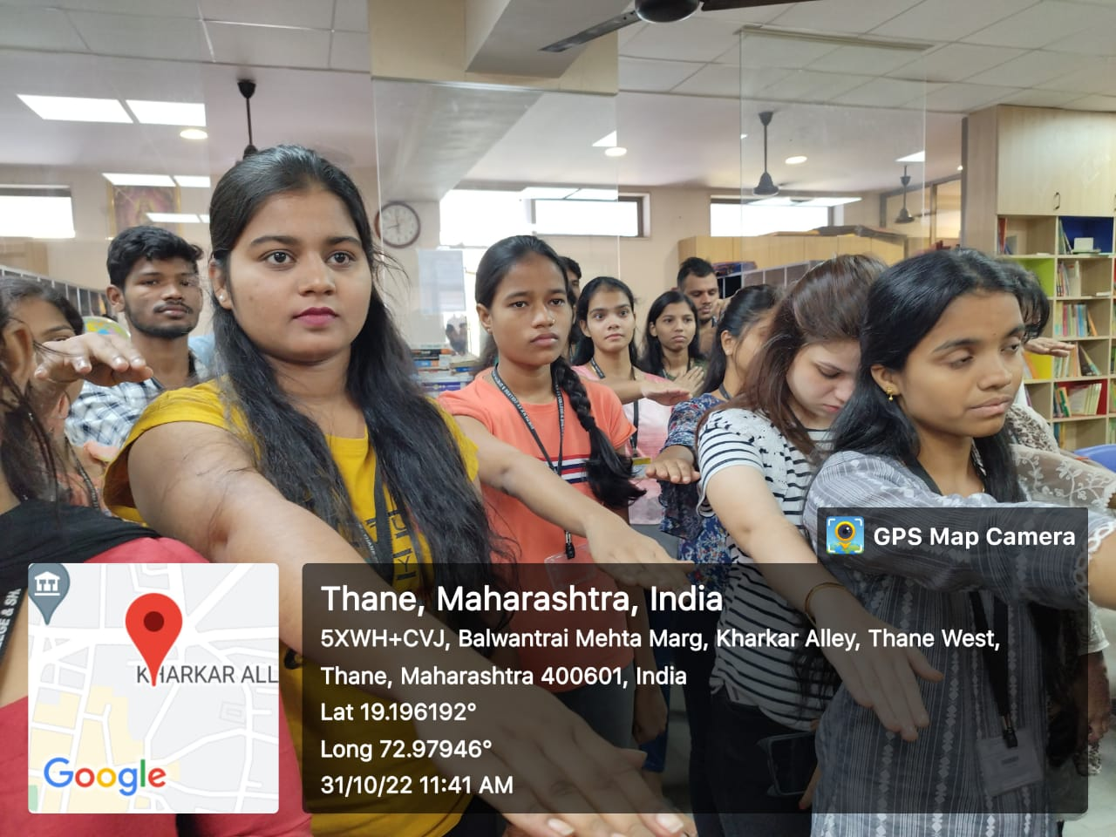
Taking oath on Sardar Vallabhbhai Patel Jayanti .

T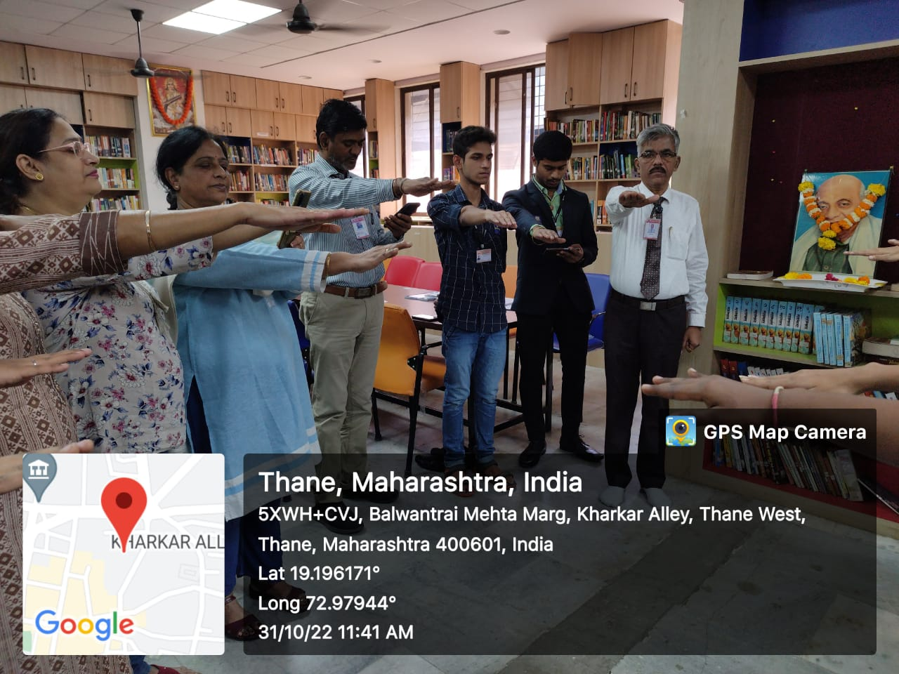

Celebrating Sardar Vallabhbhai Patel Jayanti 31st October22

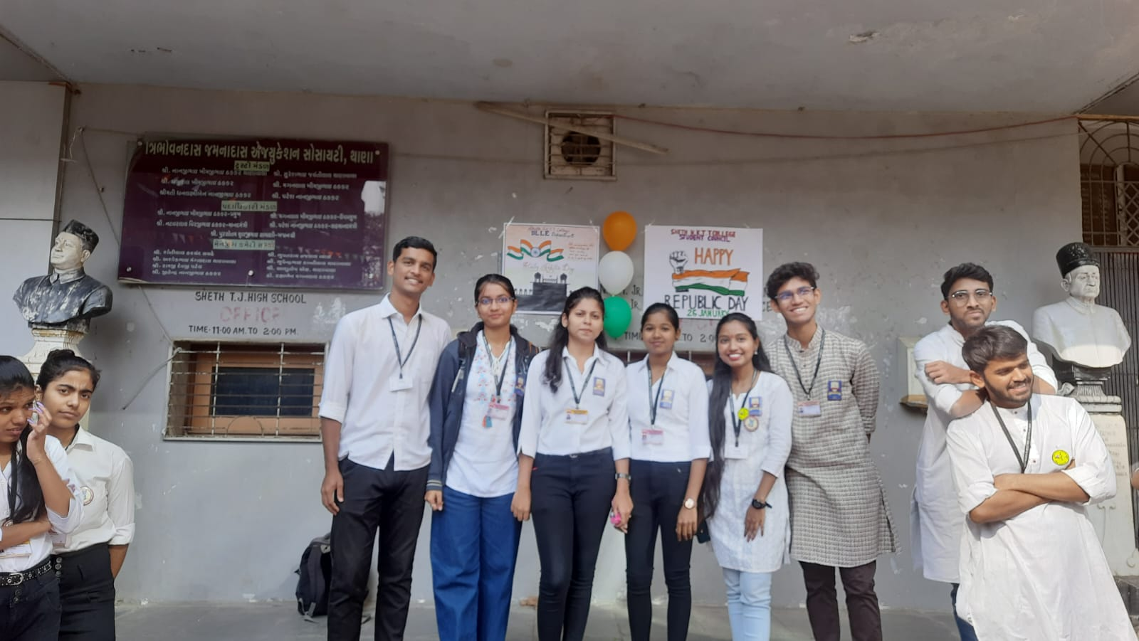
Celebrating 74th Republic day on 26th January 23
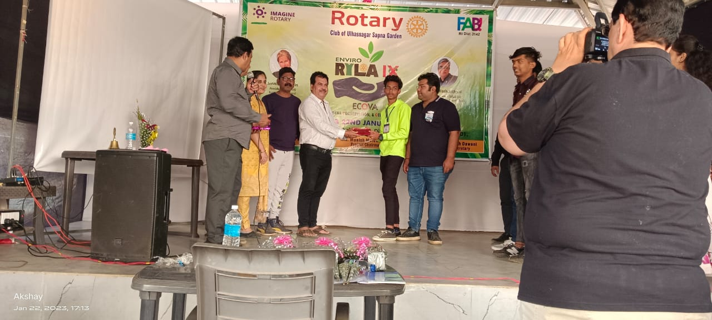
Student Council member Akash Pal won 1st prize in skit competition held At leadership programme at RILA of Rotary at Neral,Maharashtra.

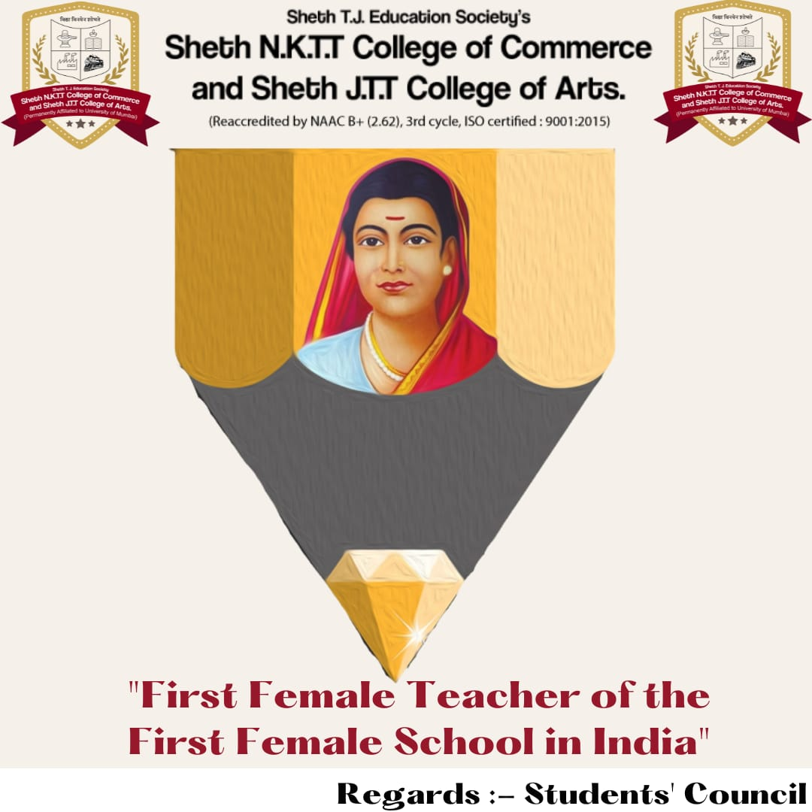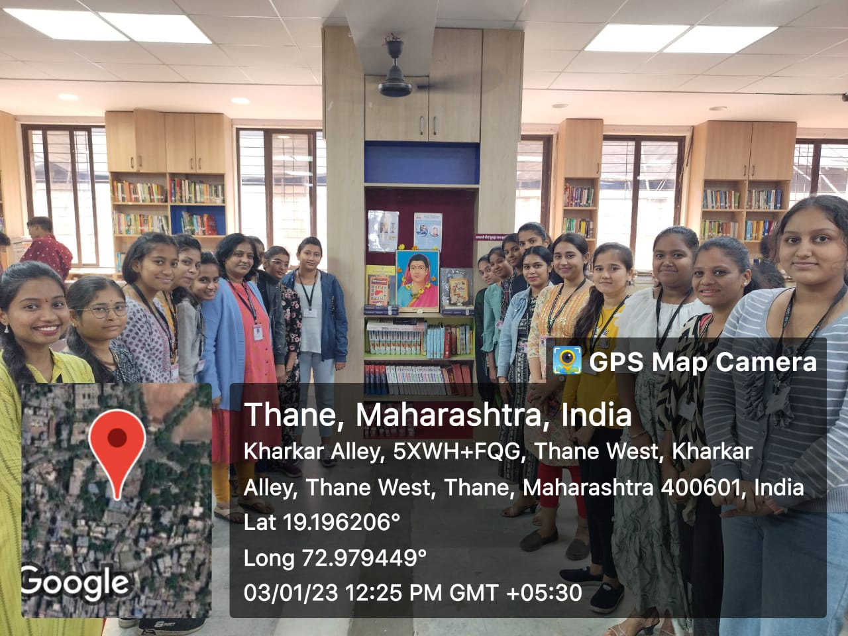Celebrating Savitribai Phule Jayanti on 3/01/23

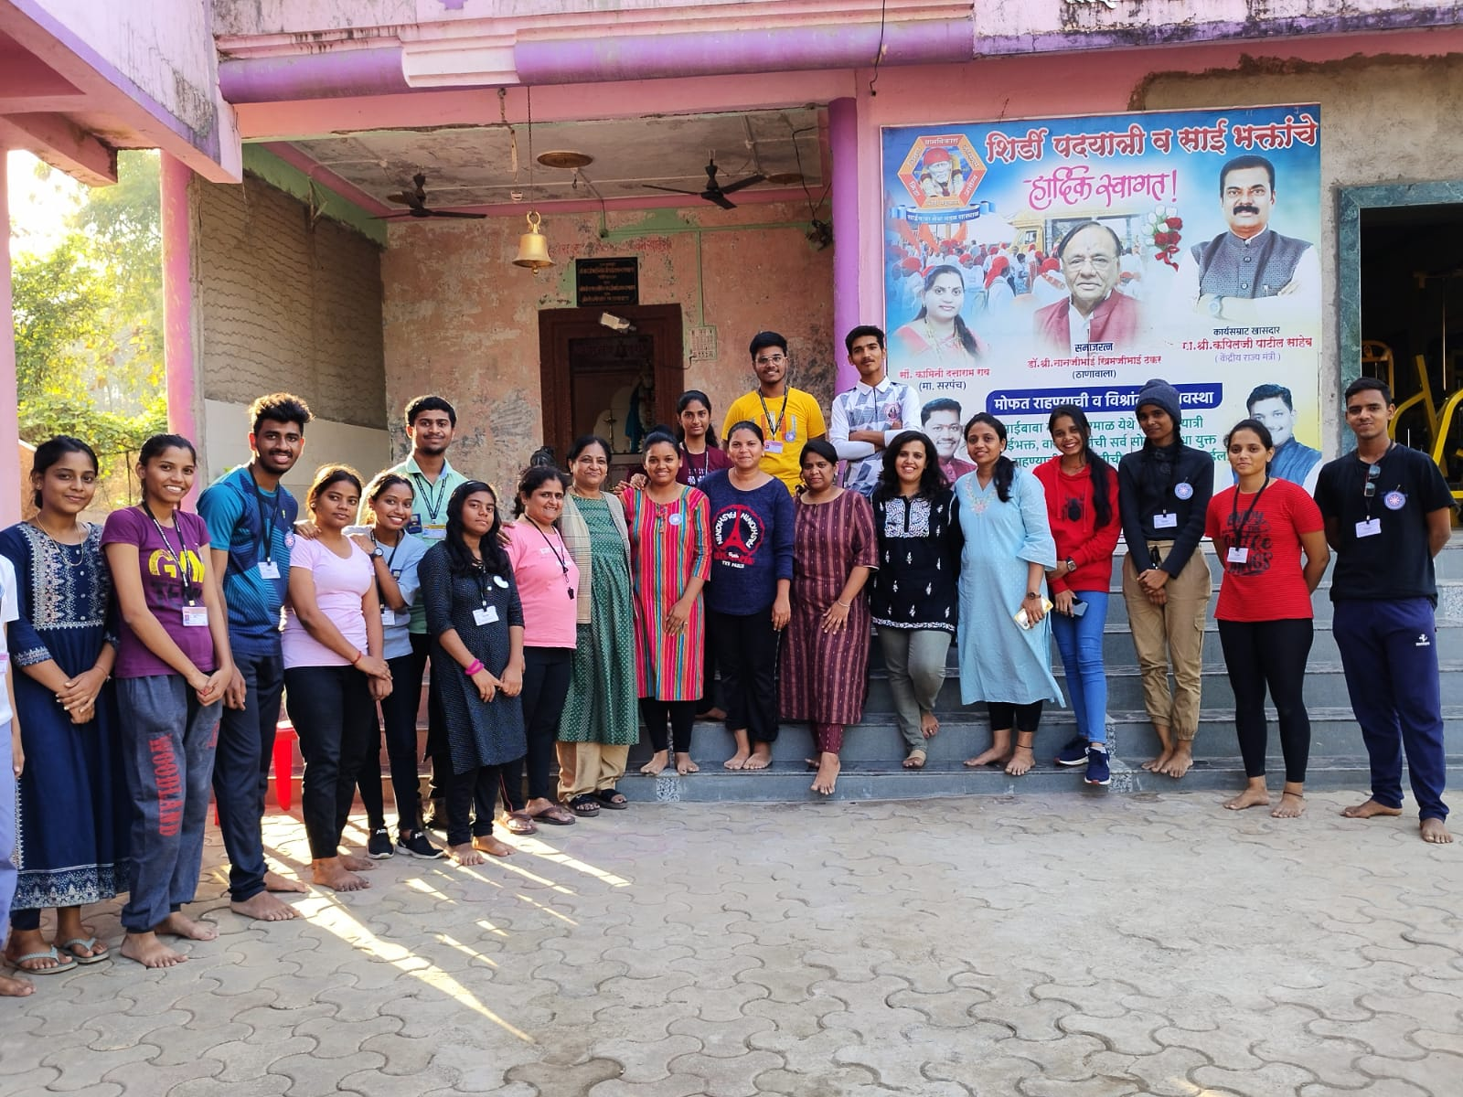
General Secretary and Ladies Representative and other student
Council members at NSS camp ,sarmale village motivating students.
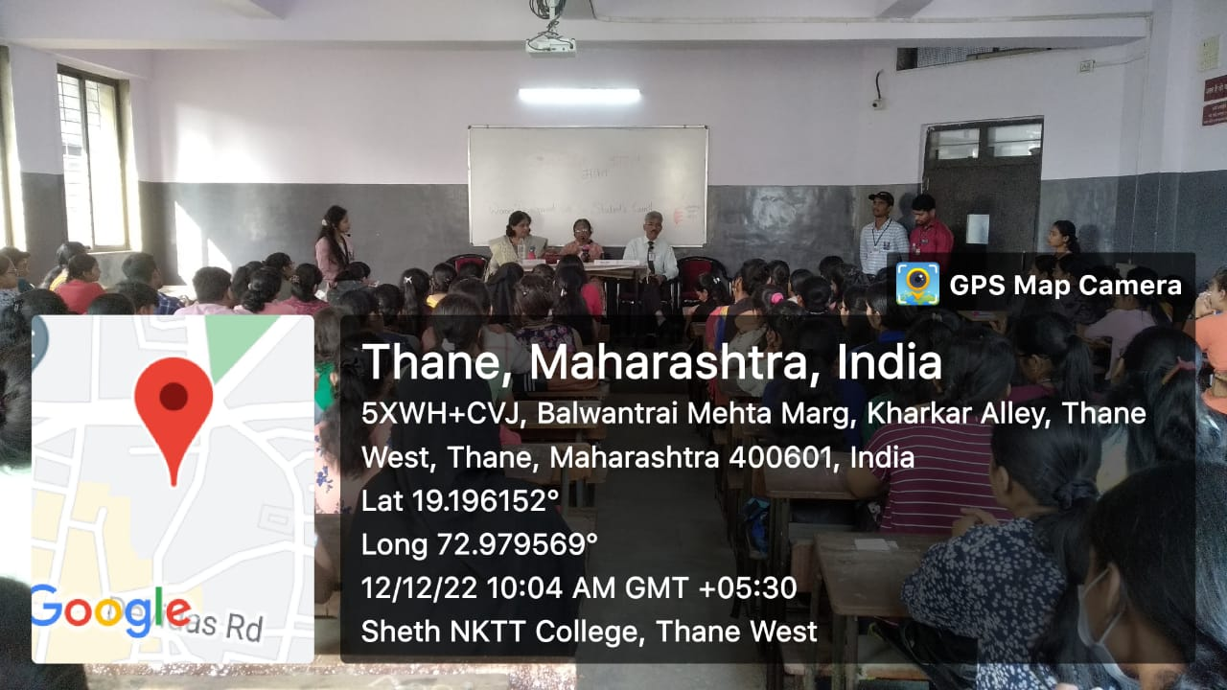
Student council members Helping WDC cell to organize
programme on anemia awareness on 12/12/22

