**REPORT**

**LITERARY ASSOCIATION INAUGURAL FUNCTION**

On 23rd September 2024, Sheth N.K.T.T College’s Literary Association hosted its inaugural function at 10:00 a.m. in the A.V. room. The program was graced by the presence of an eminent dignitary, Director DLLE, University of Mumbai, Prof. Baliram Gaikwad. The ceremony opened with lighting the lamp by Principal Dr. Dilip Patil, Vice Principal Dr. Manoshi Bagchi, and the chief guest and the Literary circle in-charge, Mr. Pranav Bhamare.

The chief guest, Dr. Baliram Gaikwad, presented his translated English version of the book *Fakira*, to the Principal Dr. Dilip Patil. The Principal, Dr. Dilip Patil addressed the students on the importance of language and literature. The Vice Principal, Dr. Manoshi Bagchi mentioned various literary events to be conducted in the span of this academic year, and urged the students to participate.

Prof. Gaikwad engaged the audience with his satirical and insightful out-takes. He urged students to participate in various certificate courses, and extracurricular activities, regardless of their respective subject areas.

“Express yourself, have the courage to step up and do it. Good communication skills will bring that confidence in you,” Prof. Gaikwad remarked. He addressed the audience further highlighting the importance of expressive poetry writing, and participation in elocution competitions. Alongside, he invited students to partake in the college magazine and bring forth their articles on social issues. Furthermore, his insights on research ability, critical thinking and participation in research conclave, also kept the curious audience interested.

Prof. Gaikwad emphasized on the importance of language, and the global avenues it can open up for one. Including how Germany is inviting over one lakh Maharashtrian applicants at present; and how being a multilingual person has numerous advantages. He shared his personal anecdote about how he utilized his lockdown time to translate his recent book, which found its place in over seven international universities.

Prof. Gaikwad stressed that training the brain to think about synonyms and paying attention to how educators speak can enhance one’s communication skills. He quoted a famous quote by J.K. Rowling, "Words are an inexhaustible source of magic." and shared a moving example of the power of words that could hurt or heal. On the topic of words being a powerful weapon, he discussed how they led him to build friendships across the globe, including his opportunity to meet Mr. Barack Obama, the then President of the USA, during his fully paid fellowship.

The chief guest, Prof. Gaikwad pointed out how science and language coexist – and hold equal importance as he noted from his recent lecture delivery in IIT Bombay. In conclusion, he asked every student to make their parents proud, and left the audience with an impactful short poem by Robert Frost. The audience highly lauded his talk. Ms. Mittal Shah proposed a vote of thanks to all. Towards the end of the event, the students recited their poems, and entertained everyone with various dance performances. Around 70 students attended the event.

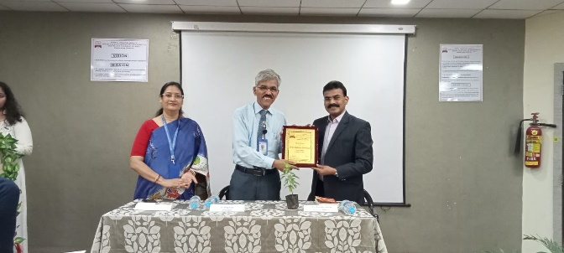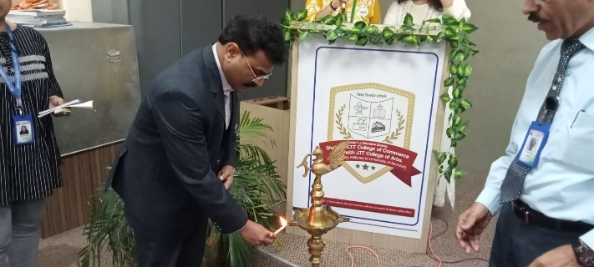

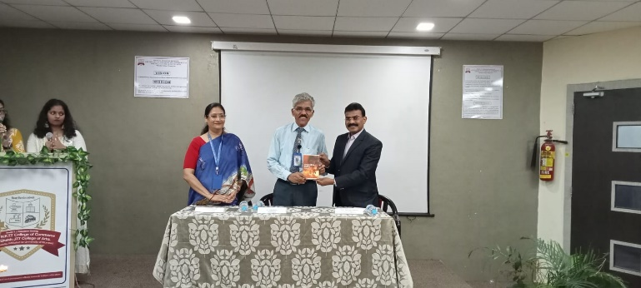 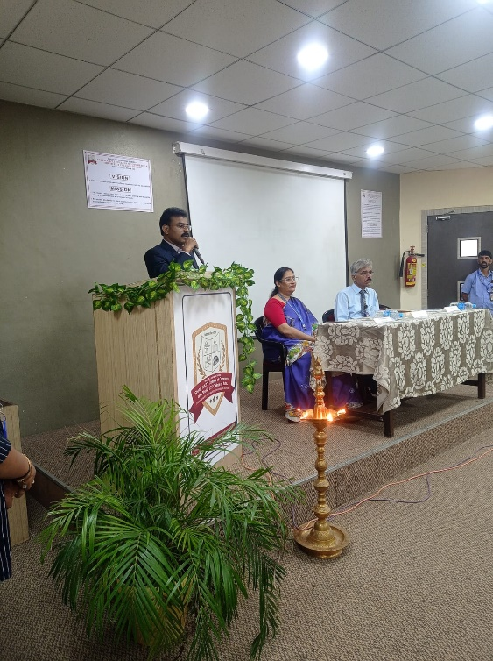

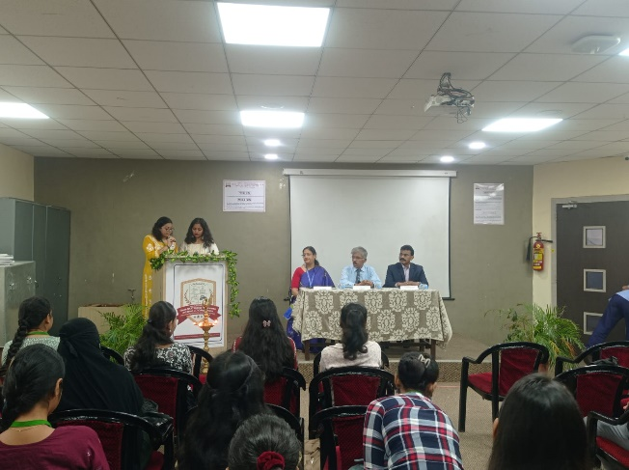 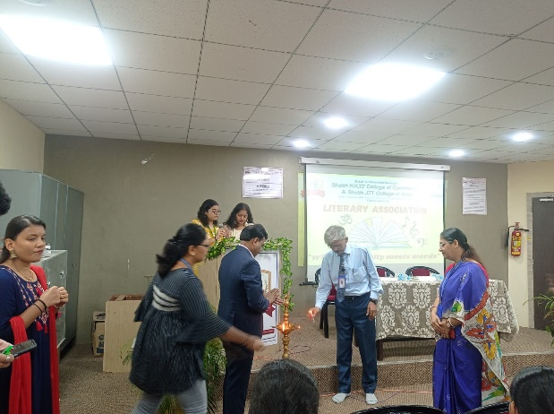

**Dr. Dilip Patil** **Dr. Manoshi Bagchi** **Mr. Pranav Bhamare**

Principal Vice Principal In-charge