Guru Purnima
Guru Purnima was held on the 3rd of July 2023. Guru Purnima (Poornima) is a tradition dedicated to all the spiritual and academic Gurus, who are evolved or enlightened humans, ready to share their wisdom, based on Karma Yoga. It is celebrated as a festival in India, Nepal and Bhutan by Hindus, Jains and Buddhists. This festival is traditionally observed to honour one's chosen spiritual teachers or leaders. It is observed on the Full Moon day (Purnima) in the Hindu month of Ashadha (June–July) as it is known in the Hindu calendar. The festival was revived by Mahatma Gandhi to pay tribute to his spiritual guru, Shrimad Rajchandra. It is alsoknown as Vyasa Purnima, for it marks the birthday of Veda Vyasa, the sage who authoredthe Mahabharata and compiled the Vedas.
This was the day when Krishna-Dwaipayana Vyasa – author of the Mahabharata – was born to sage Parashara and a fisherman's daughter Satyavati; thus, this day is also celebrated as Vyasa Purnima. Veda Vyasa did yeoman service to the cause of Vedic studies by gathering all the Vedic hymns extant during his times and dividing them into four parts based on their characteristics and use in the rites. He then taught them to his four chief disciples – Paila, Vaisampayana, Jaimini and Sumantu. It was this dividing and editing that earned him the honorific "Vyasa" "He divided the Holy Veda into four parts, namely Rig, Yajur, Sama and Atharva. The Itihasas and the Puranas are
the fifth Veda.
Various Activities were held on that day for teachers. Anchoring was done by Rugaved Narkar. Speech was performed by Kunal Yadav. Poetry was performed by Kalpita Lonkar. A video prepared by Daksh Rathod ( Representing Art Circle) for teachers for paying them a tribute. Another Speech was performed by Rinkal Bhoir (Dlle Volunteer). The Spreading Happiness Group ( Founded By Our Ex – Student). The Group Consist of following members, Lead by – Rahul Rathod & Raunak Panchal. Ladies Representative – Roshni. Other Members – Rahul Dharne, Tanvi Jagtap, etc.
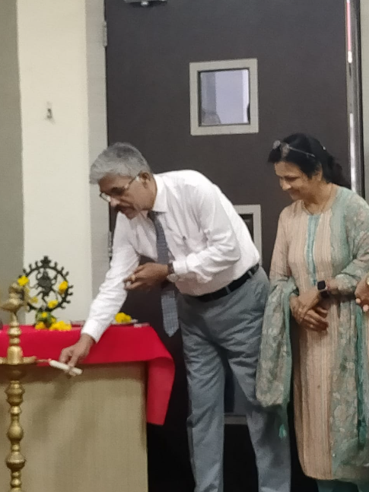
Lighting of Lamp
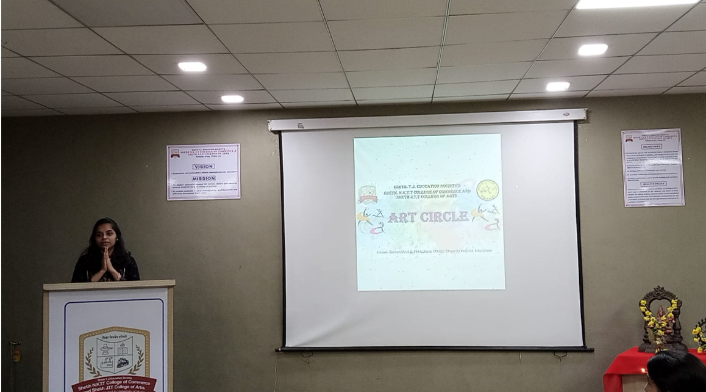
Students paying their tribute to teachers with Sanskrit vandana

