UDAAN FEST
16th February, 2023
DLLE Committee of our Sheth N.K.T.T. The college participated in the Udan Fest organized by the Department of Lifelong Learning and Extension, University of Mumbai at B.N. Bandodkar College on 16 February 2023. The objective of Udaan Fest is to increase knowledge and awareness among students. Our college participated in various competitions offered by Udaan Fest, which included – street drama competition, elocution competition, poster making competition and creative writing competition.
Our 20 volunteers including 3 Student Managers had participated there with full enthusiasm. And our two Extension Teachers also came to guide and encourage us regarding the competitions. The competitions started at 11 am. Various teachers and the DLLE field coordinator Ms. Vinda Manjramkar were present there.
A total of 33 colleges all around Maharashtra participated in the UDAAN FEST. And from those, 23 colleges had taken part in the Street Play Competition. At the time of results, our college got 1st consolation prize in the Street Play Competition. Whereas 26 colleges had participated in the Elocution Competition from which we won 1st prize in the Elocution Competition.
The moment of achievements were appreciable for all the volunteers. Our joy doubled by receiving the trophies and certificates. And it became a proudest honor for our college.
At the end we want to thanks to Ms. Vinda Manjramkar, the field Coordinator for her valuable guidance and a grateful thanks to our Extension Teachers Dr. Dhanashree Sawant & Ms. Siddhi Valanju for their unique and equal contribution towards developing our personality.

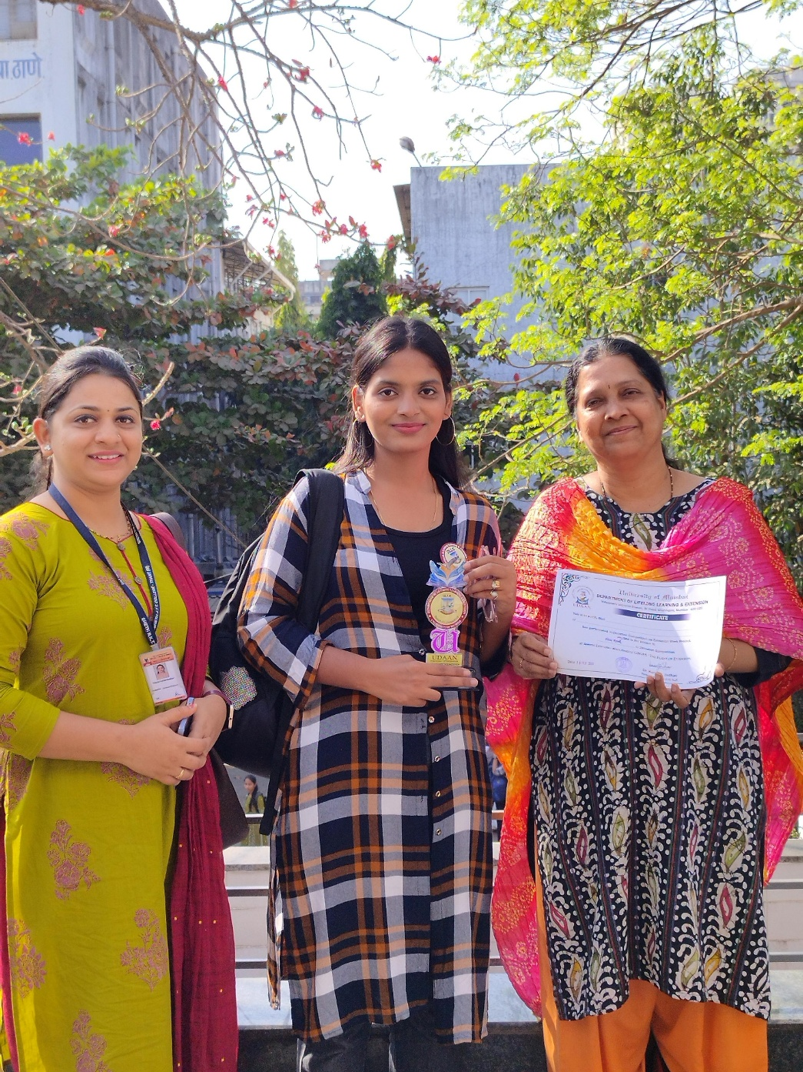

ELOCUTION 1 PRIZE

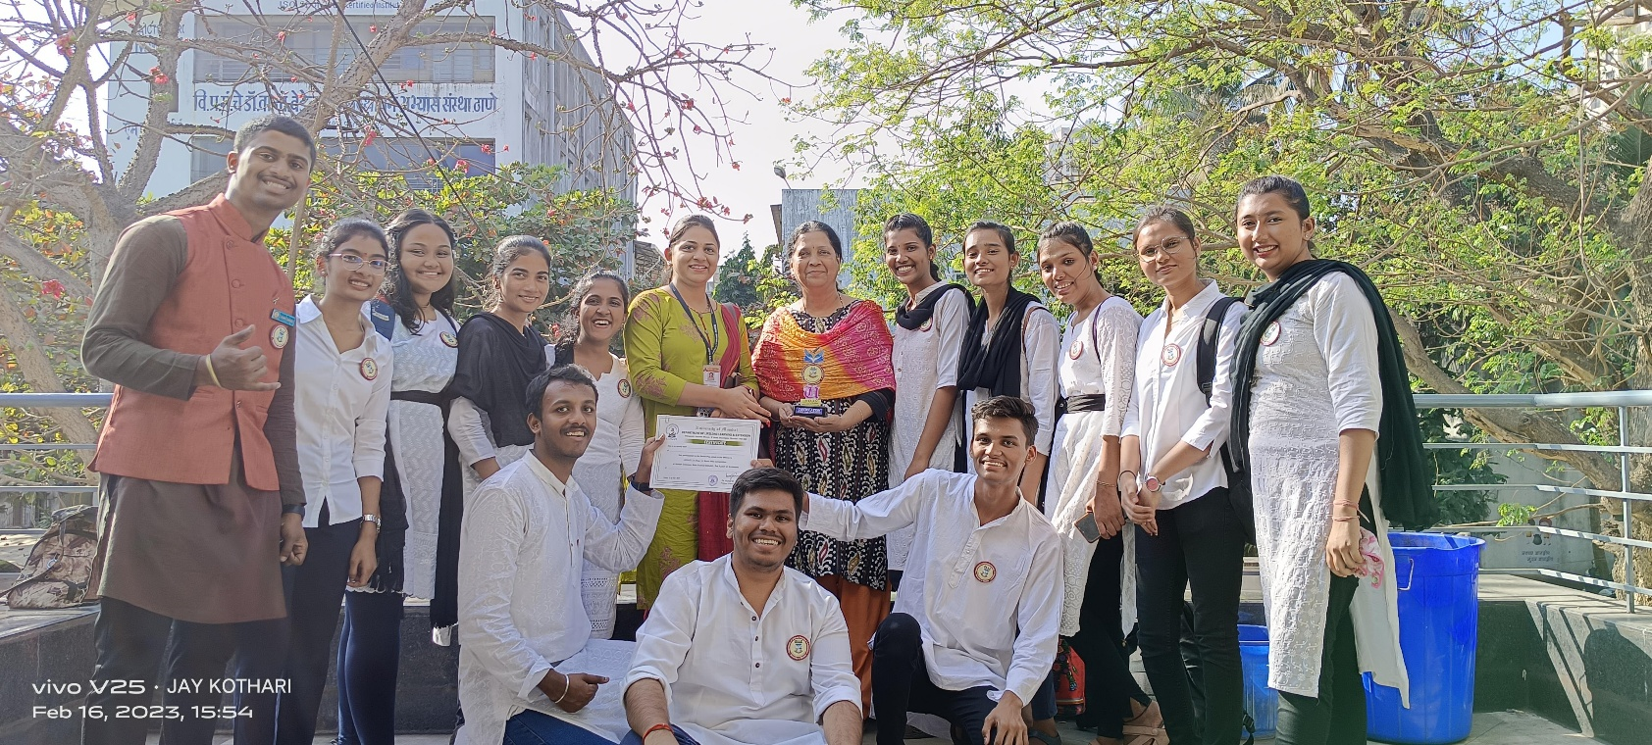
CONSULTATION 1 PRIZE

