Deeksharambh – Student Induction Programme is organized in Sheth NKTT College, Thane.
Deeksharambh – Student Induction Programme is to help new students adjust and feel comfortable in the new environment, inculcate in them the institution's ethos and culture and help them build bonds with other students and faculty members. Therefore, to guide the students Art Circle of Sheth N.K.T.T. College of Commerce & Sheth J.T.T. College of Arts organized the Student Induction from 24th July to 26th July 2023.
The program started with the University Anthem and State song. Principal Dr. Dilip Patil addressed the students. Vice Principal Mr. Anil Khadse gave the introduction of the college. Convenor of Art Circle Dr. Pallavi Shah gave information regarding Student’s Council and Extra – Curricular Activities in college and part-time earnings. Faculty members gave detailed information regarding their respective committees and honorable president Samajratna Dr. Sheth Nanjibhai Khimjibhai Thakkar Thanawala guided the students. The program ended with the National Anthem. Principal Dr. Dilip Patil appreciated the Art Circle for the smooth conduct of the program.

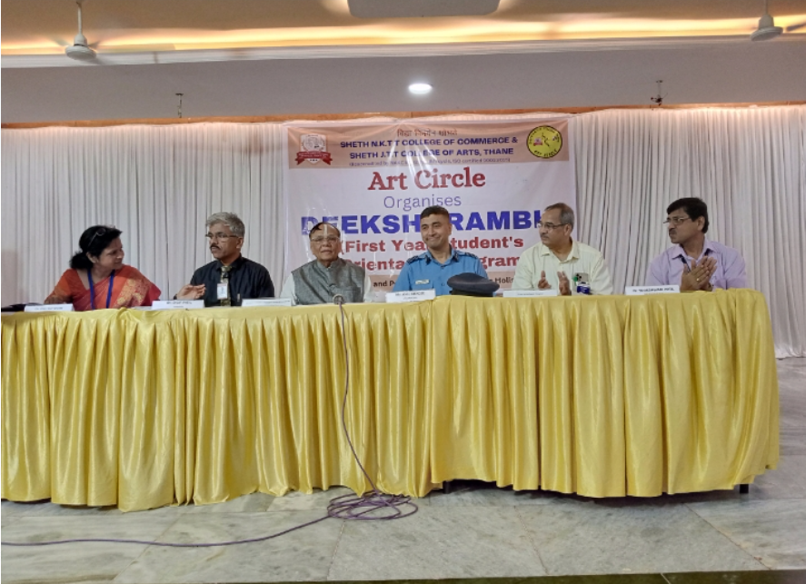
Chief guest Group Captain Mangesh Nilangikar

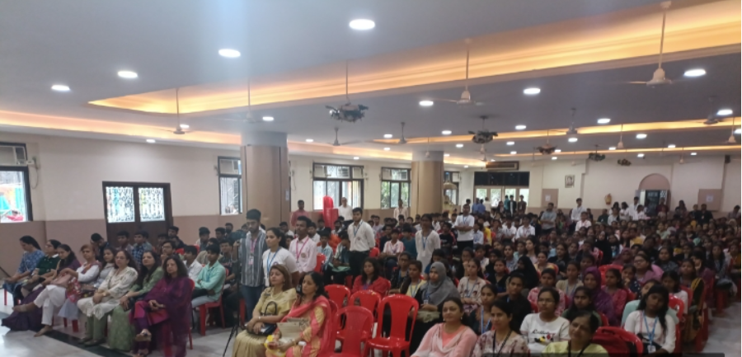
Staff with students on Orientation Programme

