Sheth T.J. Education Society’s
Sheth N.K.T.T College of Commerce and Sheth J.T.T. College of Arts, Thane.
ANVAY – Ex Students Association
ANNUAL REPORT – 2021-22
ANVAY – Ex Students Association is an Association consisting of Convener, Teacher Members and Distinguished Alumni of the College.
Aims and Objects
1) To act as a link between the “Alma Mater” (Sheth NKTT College, Thane) and the
“Alumni” (the past students).
2) To provide a platform for interaction between alumni, present students, faculty of the
college and college administration.
3) To conduct seminars and workshop for the students.
4) To guide the students with developing contacts for academic enrichment.
5) To provide career and vocational guidance to students.
Composition
For the year 2021-22 composition of the Committee was as follows:
- Ms. Dipalee Mulmulay – Convener
- Mr. Abhay Sawant (Alumni) – President
- Adv. Chetan Baraskar (Alumni) – Secretary
- Mr. Harnesh Dedhiya (Alumni) – Treasurer
- Ms. Sujata Gada – Teacher Member
- Ms. Namrata Sawant – Teacher Member
Activities During the Year
On 17th December, 2021 a meeting of ANVAY – Ex-Students Association was conducted for discussing and deciding about Registration of ANVAY - Ex-students Association as Trust. This meeting was conducted in the College in Conference Room at 10 am. The resolution to register the Association was passed unanimously. Advocate Chetan Baraskar was given authority to initiate the process of registration. Accordingly the application was submitted to the competent authority for registration. The Association is successfully registered under Societies Registration Rules, 1860 w.e.f. 24th February, 2022 bearing registration No. MAHA/254/2022. The President of the Association is Honourable Principal of the College Dr. Dilip Murlidhar Patil. Vice President is Mr. Abhay Maruti Sawant, while Secretary is Adv. Chetan Vishwanath Baraskar. Other members of the Association are Mrs. Sujata Jignesh Gada, Ms. Bhavika Shashikant Khadapkar, Mr. Jitesh Thimappa Poojari, Mr. Jairam Lalman Yadav, Mr. Harnesh Ramnik Dedhiya, Mr. Kazi Mohd. Zaid Riyaz, Ms. Manjushree Satish Hegde and Ms. Namita Kedarnath Bhatra. The registration of Association in front of the Charity Commissioner under Maharashtra Public Trust Act, 1950 is in process.
On 25th September, 2021 Association with Department of Business Law organised Webinar on ‘Life Skills for Stress Management’ on at 10.00 AM through Google Meet platform for students of this college. Resourse person was Ms. Aarti Girish Hugar – Ex-student, Manager (Compliance) at Venkys Uttara Impex Pvt Ltd. Pune. Total 400 students attended the webinar. E –Certificates were given to all the participants. On 5th February 2022, Department in Association with ANVAY – Ex-Students Association conducted Webinar on “Intellectual Property Rights’. The webinar was divided in three sessions. Resource Person for session I was Adv. Ishita Kasar who has successfully completed her master’s degree in Law with Specialisation in IPR and who is daughter of our own employee Mrs. Bhagyashree Kasar. This session was conducted through hybrid mode. The topic was ‘Trade mark and to Current Case Laws’. Resource person for session II, which was conducted online, was our Ex-student Adv. Ashok Pote who is practicing advocate in Mumbai High Court and has completed his degree of Law with Specialization in IPR. The topic was ‘IPR with special Reference to Copyright’ In last session, Students were given to solve the quiz based on sessions. Students who attended all sessions and scored minimum 40 percent in quiz were awarded with E-Certificates. Total 216 students attended the webinar.
On 26th February, 2022, members of the association Mr. Abhay Sawant, Adv. Chetan Baraskar and Mr. Jitesh Poojari, visited NSS residential camp. They guided students and also conducted ‘Answer the Question and Win A Book’ Contest. Books were given as prizes. NSS Volunteers actively participated in the contest.
First meeting of ANVAY trust 30th April, 2022 in which various issues were discussed like planning for the next academic year, admission of members etc.
Association thanks Honourable Management and respected Principal Sir for their support and guidance, and especially for initiating the procedure for registration of the Association.

Convener Principal

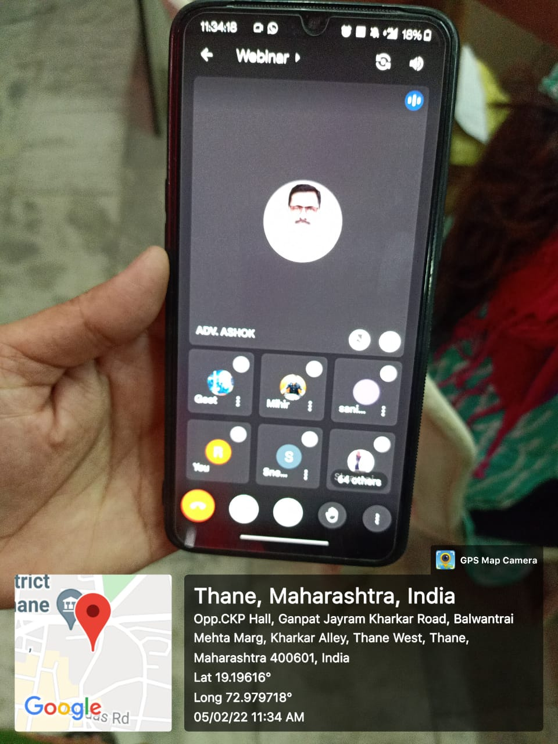
Figure 1Webinar on “Intellectual Property Rights” by Department of B. Law in Association with ANVAY – Ex-Students Association on 5th February, 2022

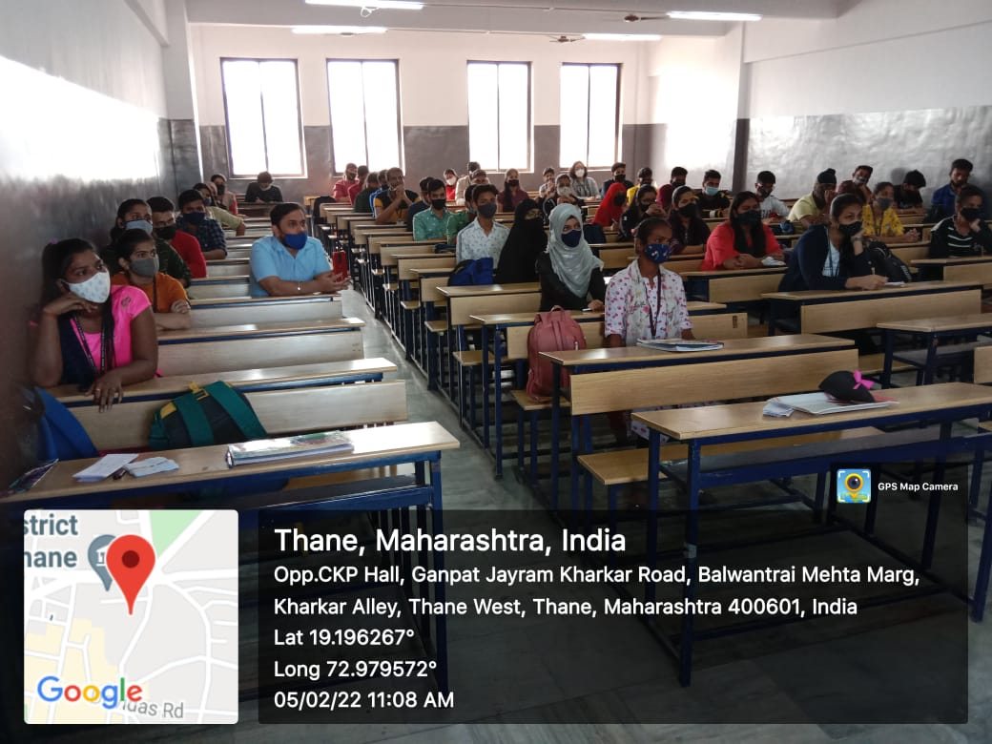
Figure 2Webinar on “Intellectual Property Rights ‘Department of B. Law in Association with ANVAY – Ex-Students Association on 5th February, 2022

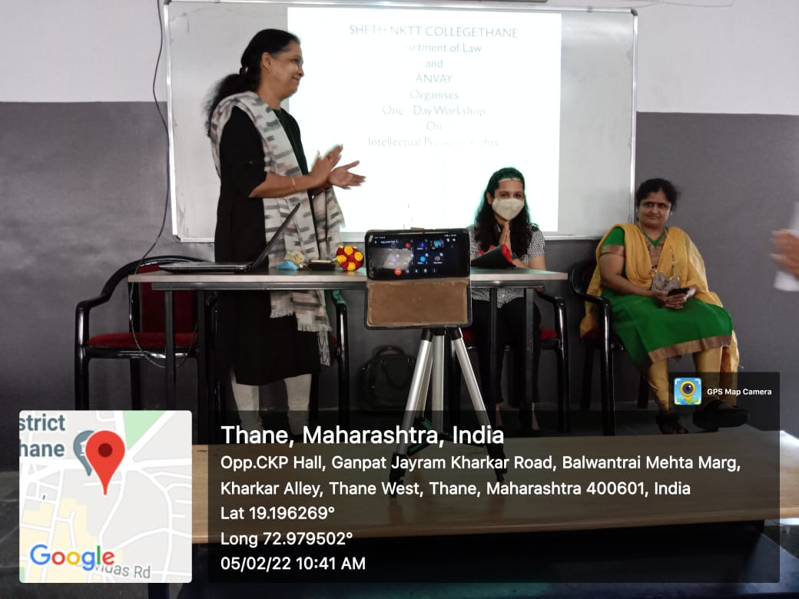
Figure 3Webinar on “Intellectual Property Rights ‘Department of B. Law in Association with ANVAY – Ex-Students Association on 5th February, 2022

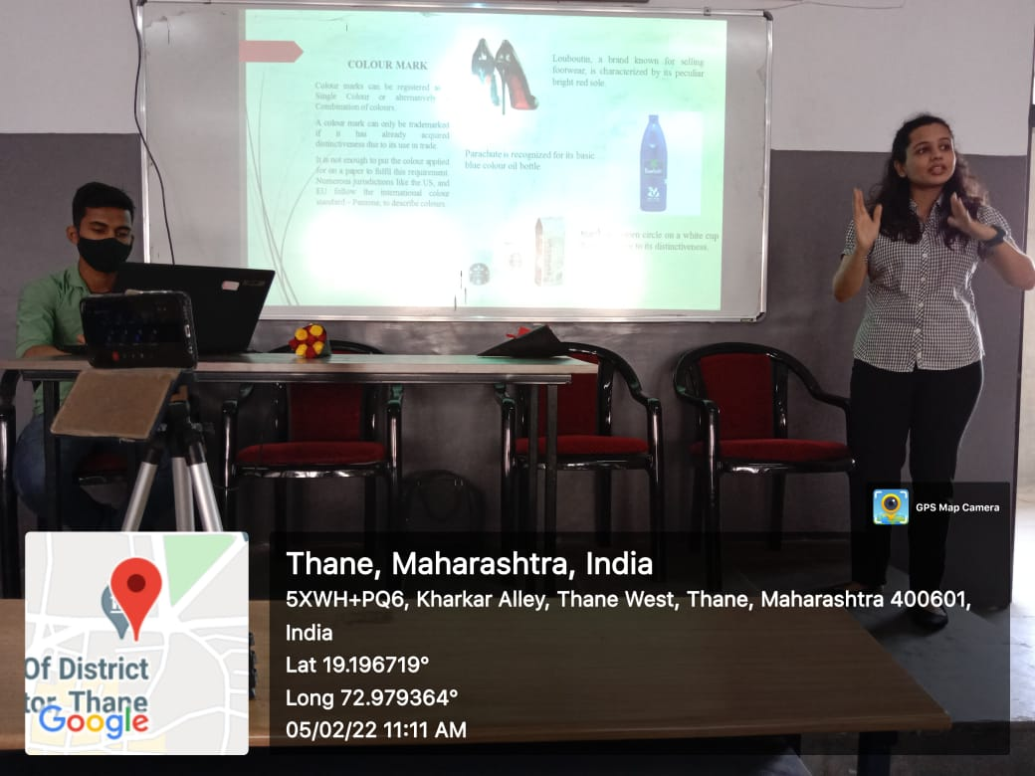
Figure 4Webinar on “Intellectual Property Rights ‘Department of B. Law in Association with ANVAY – Ex-Students Association on 5th February, 2022

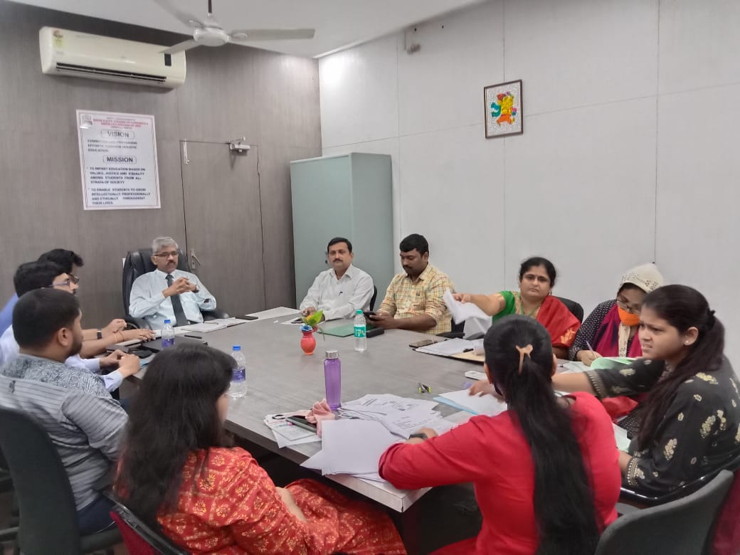
Figure 517th December, 2021 a meeting of ANVAY – Ex-Students Association for discussing and deciding about Registration of ANVAY - Ex-students Association as Trust.

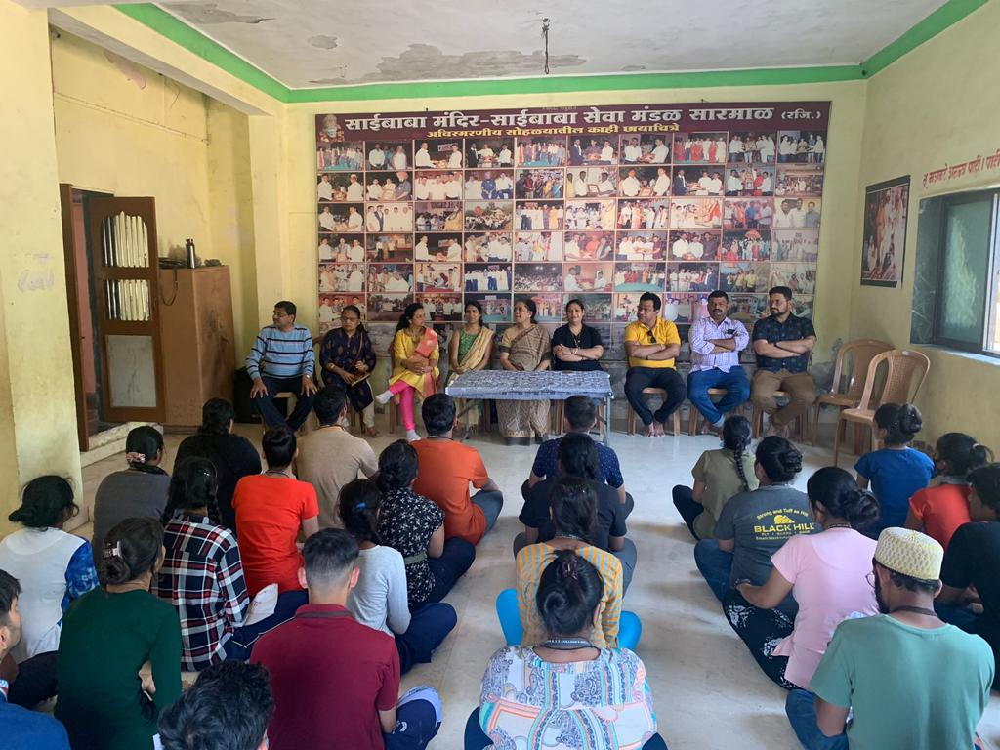
Figure 6Visit to NSS residential camp 26th February, 2022
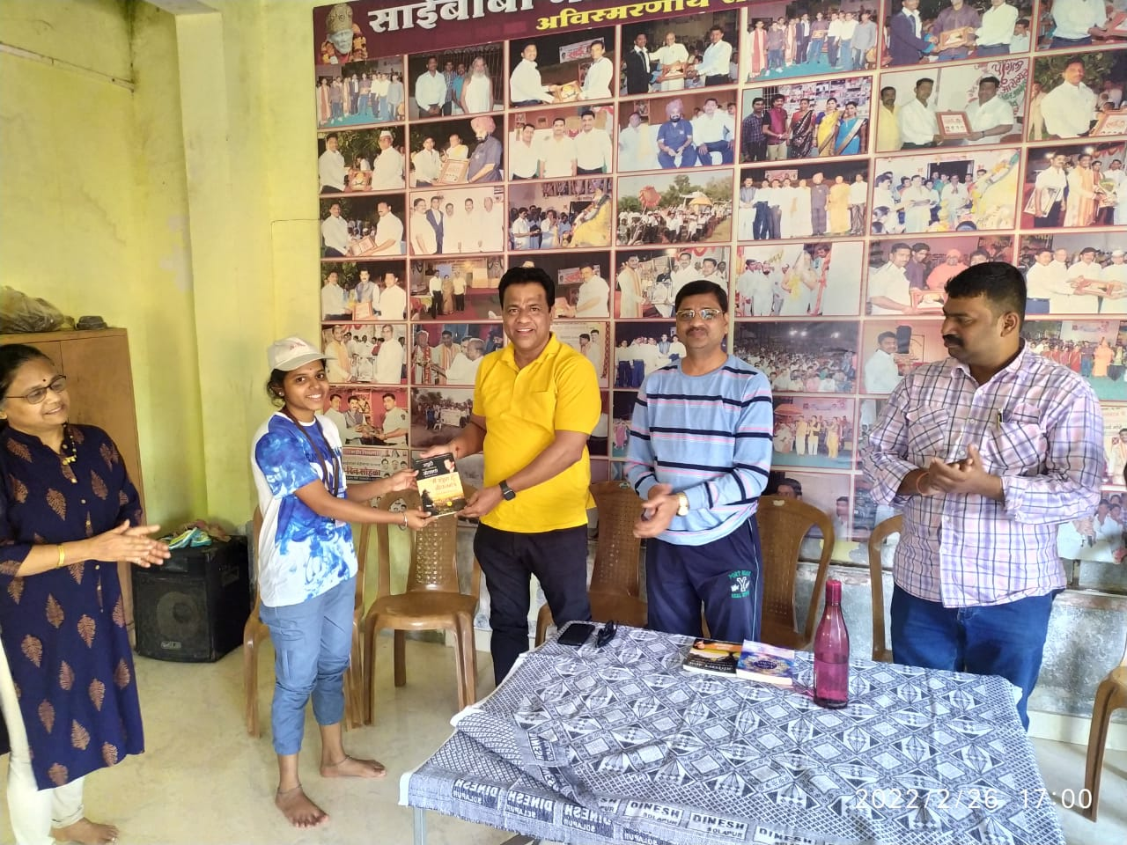
Figure 7Visit to NSS residential camp 26th February, 2022

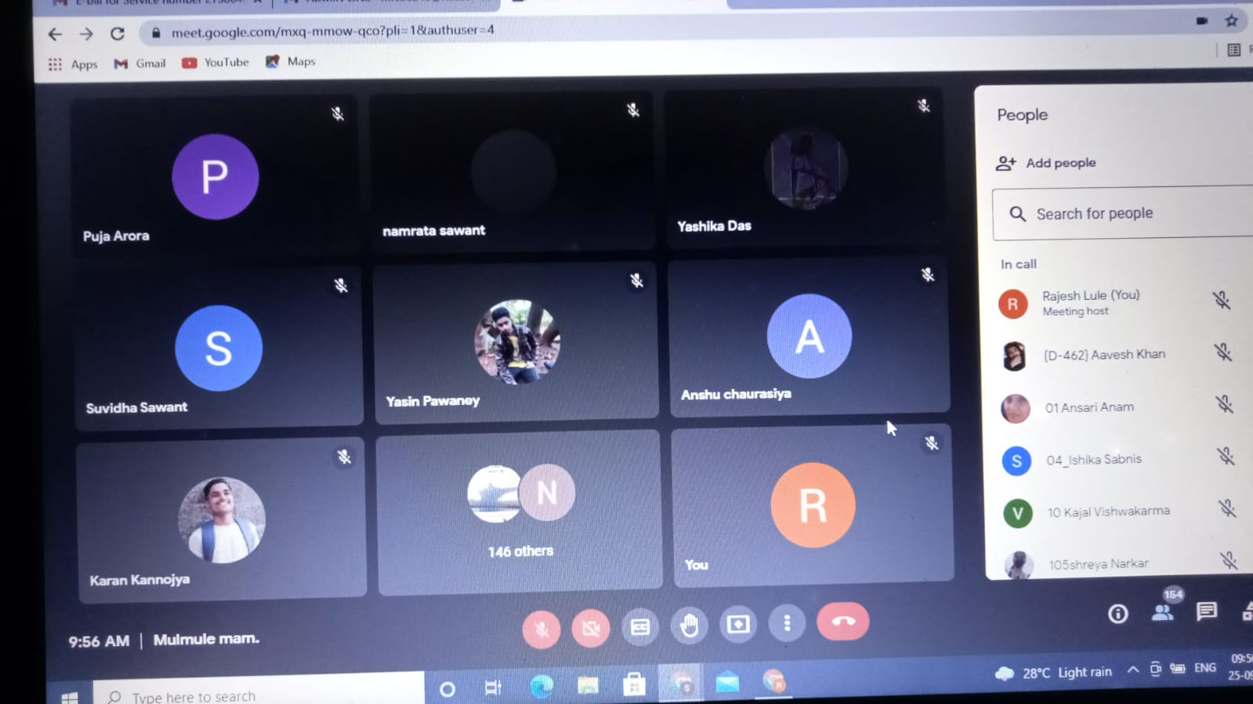
Figure 8Webinar on ‘Life Sills for Stress Management’ on 25th September

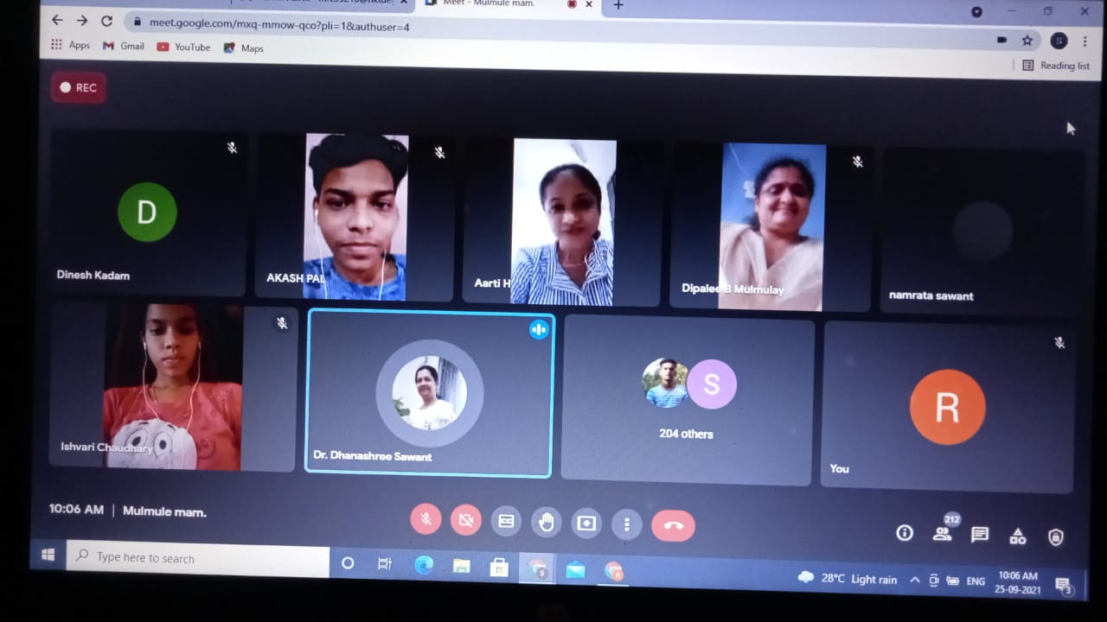
Figure 9Webinar on ‘Life Sills for Stress Management’ on 25th September

